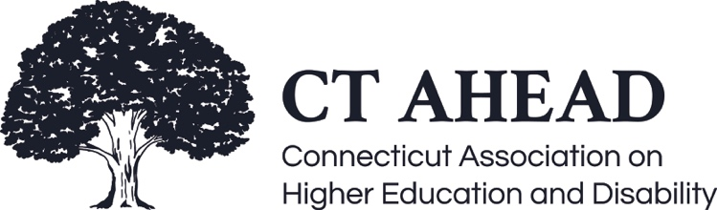

Meeting Minutes - September 24th, 2021

CT AHEAD Member Roundtable Meeting

Brooks called the meeting to order at 9:06 am (14 in attendance)
- Decision made not to record the meeting to allow members to speak candidly and allow for open dialogue. A transcript and captions were available for those in the meeting; however, the transcript will not be saved or shared to allow for open discussion again. Future meetings involving guest speakers or presentations will be recorded and shared with all members.
- Brooks introduced Board Members, and all members in attendance provided an introduction to their role and institution.
- Reviewed dates of future meetings and intent for each:
- October 22, 2021 – not a formal meeting but will be continuing our community chats. The goal will be to review CT AHEAD’s current mission and see if our language is inviting to expand our membership and is in line with our future plans.
- December 3, 2021 – meeting on assessing trends and quantifying data to help support retention and who we are serving. We are looking to evaluate how to expand upon just head counting and evaluate the data to support our administrative needs better.
- February 11, 2022 – the topic is transition-in and discussion on bridging the gap from high school to college. We will look to have CT Counselors join us for the conversation.
- March 11, 2022 – not a formal meeting but our second community chat on transitioning out. The focus will be on employability and what we can tangibly provide to our students as they exit college.
- April 1, 2022 – business meeting roundtable discussion.
- If any members have expertise or resources to share for the community chats or are interested in volunteering to act as a facilitator, please let us know.
- Discussion regarding patterns or trends members are seeing on their campus this year:
- Resiliency for social events has decreased for individuals with disabilities and those without.
- Other institutions have identified similar trends where campus clubs have decided to take a break because the process of being involved was overwhelming for many.
- Burnout and the burden to be around people have extended out from not just students but also employees. Some have identified that it has been a challenge for many even to consider being in events where groups of people attend.
- Discussed the fact that we essentially now have two years of first-year students on campus.
- Many more students have already gone on medical leave now than in the past.
- Students are struggling more with how to interact with others. Their battery is getting drained more quickly than in the past. Members have identified that this is something they are dealing with as well. In our rush to get back to campus to provide the “college experience” for students, we realized that we may have needed a more tapered approach.
- Mental health issues have seen an alarming increase. More hospitalizations, suicide attempts, and dark thoughts this semester than in past semesters.
- This trend is occurring not only at the college level but also in K-12.
- Issues with why the option to remain virtual is not available. If it was okay a year ago, why can’t it be an option now for those that need it?
- Craving for connection is there, but we struggle to connect on a social level since we are all healing individually as we return to our new “normal.” We need to brainstorm ways to get students to a place where they feel like they are part of a community again. While there is anxiety around the social aspect of things, there is a strong desire to connect on many other levels with adults and peers.
- On an accommodation level, offices are inundated with more students registering because they may not have needed the support while online, but now back to campus, they are needing accommodations.
- More concerns now with students on information overload. For the past year, all course information may have been loaded into Blackboard, and now with the shift back to campus, students are struggling with auditory processing, taking notes, being able to multitask, executive functioning.
- Discussion on challenges/benefits when Disability Service Office is part of Student Success Center.
- Holistic wraparound type of support is provided when partnering with the Student Success Center.
- While tutoring helps to ensure success, Disability Services does not. Expectations need to be clear.
- Faculty have been more receptive to referring students to the Student Success Center without navigating the sensitive nature of disability.
- Students are more apt to ask for support when they come to the Student Success Center and then ultimately find more assistance through the Disability Services Office
- Faculty seem more receptive to Disability Services when partnered/joint services with Tutoring/Student Success Center.
- Self-care of Disability Service Providers
- Establishing and maintaining our office hours is essential so that we don’t set an expectation that we are available at all times.
- Setting healthy boundaries on work hours is needed so that we can recharge our battery.
- Need to define the separation of work and home so that we don’t burn out.
- Practice eliminating the urgency of instant gratification that many have come to expect where emails need to be replied to immediately.
- Setting blocks of time to check emails or other work tasks to help with productivity.

Meeting ended 10:20am

Respectively Submitted,

Debbie Kosior
CT AHEAD Secretary

