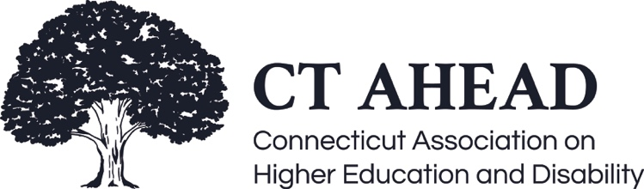

Meeting Minutes – December 3, 2021

CT AHEAD Transition-In

Brooks called the meeting to order at 9:05 am (13 in attendance)

The Purpose of the meeting was a community chat on Transition-In from high school to postsecondary education.

Padlet on Transition-In
- Brooks shared a Padlet they created when presenting to students, prospectives, families, and internally on campus, regarding the transition-in process and how disability services works in college. The Padlet is organized in a timeline format and covers topics such as disability pride and identity, identity first, and person first language, laws and rights of students with disabilities, differences between high school and college disability services, reasonableness of accommodations, documentation guidelines, and the intake. Emphasizing how important the interactive, case-by-case process is in determining accommodations.
- Brooks also shared how they divide out the interactive process outlining the roles of the student, Disability Services (DS), and the instructor. By informing them of this information, everyone understands that the interactive process is not just between student and DS, or student and faculty, but rather a combined effort.
- Brooks discussed the movement away from the Medical Model of Disability and some of the various barriers that students are up against: attitudinal, institutional, environmental, and internalized. Stress is on the importance of accessibility.
- Brooks presents this information every year to the Connecticut Counseling Association.

Member Feedback and Discussion on Transition-In
- The Padlet will be uploaded to the CT AHEAD website for anyone to use to help guide discussion around transitioning to post-secondary education.
- Members agreed using a tool and resource such as the Padlet in a comprehensive way is helpful to guide students through the transition process and what to expect once in college. Having a standardized and structured tool/infographic available helps provide consistency for all students and helps to share the essential information in a more simplified, easy to understand way.
- Transition info is extremely important to help inform parents who have generally been integral in the K-12 process of setting up accommodations for their child. It is a difficult process sometimes for the parent to let go. Providing students with the skills they need so they can learn to self-advocate helps them to take ownership over their disability. This is a skill that students can develop and carry with them long after they graduate. Helping students understand the importance of barrier removal, and being able to inform us of the barriers they face helps us to work with them on navigating around them.

- How can we make this transition information available to individuals at the secondary level? Many high schools and school counselors are not fully aware of the specifics regarding the postsecondary disability process. This info should be available prominently so schools and families understand how the process changes and what to expect in college. It is helpful for high schools to tour colleges with students, see the Disability Services Office, and learn about the services available. CT AHEAD should be used as a resource in offering to present this information either in-person or virtually through discussions and workshops.

Looking Ahead
- Many think of college as the end goal, but much of what we are discussing goes beyond college. It is our goal to provide students with the tools they need to help them with self-advocacy long after graduation.
- Higher education is about community. Providing students with a club on campus aimed at disability identity helps establish the peer perspective and provides students with a sense of community and belonging. Peer-to-peer support is sometimes the best way to get information out because students can interact with other students just like them while learning the ins-and-outs of post-secondary disability services.
- Student interns and peer advisers registered with the Office of Disability Services are another helpful resource to guide students through the disclosure and disability process in college. Having students in a role like this helps to reduce the stigma associated with disability and normalizes that disability is just one more aspect of diversity on the campus. This helps students feel more pride in disclosing and owning their disability.
- There is a cultural shift that is beginning to occur where minoritized groups are seeing an increase in the sense of community. In time, it is hopeful that there will be more acceptance and opportunity in realizing that individuals with disabilities are a rich community that provide and contribute to society.

Meeting ended 9:54am

Respectively Submitted,

Debbie Kosior
CT AHEAD Secretary

