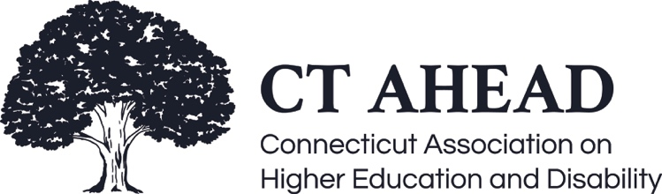

Meeting Minutes – February 11, 2022

CT AHEAD Quantifying Data

Brooks called the meeting to order at 9:05 am (15 in attendance).

The purpose of the meeting was to evaluate other ways to use data that moves beyond simply counting students—finding out how we can provide a detailed assessment of our office by evaluating data and trends. We were joined by Crystal Cyr, Student Affairs Assessment Specialist at the University of Colorado Boulder (CU Boulder), who presented on CU Boulder’s assessment process and methodology.

The presentation outcome looked to provide ways to analyze data that we already have, identify new data sources, and interpret data to help change and improve our programs.

The purpose of data collection and assessment has shifted through the years from a compliance model for accreditation to a more meaningful model where we can see how effective our programs are. This helps us to align and deliver our programs in ways that meet our intended goals.

Through data, we can identify our strengths and weaknesses and make changes with the intention of improving areas and student experience.

In assessment, we use outcomes-based language by focusing on the outcomes we want to achieve and then collecting meaningful data.

Two outcomes to consider:
Process outcomes/objectives – what we are trying to achieve operationally (e.g., processing time, accommodation requests, etc.). The focus is on what we are delivering. Some data sources that might be useful in identifying and measuring this might be surveys, focus groups, document analysis we have on file, and database review of student records.

Learning outcomes – what we want students, faculty, or staff to learn or be able to do as a result of interacting with our area (e.g., skill development). To begin a learning outcome, it is helpful to begin with, SWiBAT (Students will be able to) + Bloom’s Taxonomy Verb + activity + condition. For example, students will be able to describe the process of requesting accommodations as a result of participating in an intake appointment. Some data sources to assess learning outcomes might be surveys, observations, post-training assessments, and informally asking students.

Assessing student learning can be done either directly (open response) or indirectly (checklist/rubric) to demonstrate the level of understanding for the learning outcome.

Some data points that members discussed using for assessment:
- Number of students coming through the Disability Services Office
- Disability categories
- Accommodation categories
- Number of students enrolled
- Number of students eligible for accommodations
- Total number of accommodation letters sent
- Average GPA
- Number of students coming in for coaching support
- Retention rate

Some ways to use data:
- Helps to inform training opportunities
- Customer service improvement
- Advocate for students on campus
- Helps to inform advisors on campus and educate them on supporting students with disabilities

A recommendation is to do a landscape review, evaluate all data sources, and then develop other opportunities for data collection. Look for ways to make data collection fun for students where they can provide feedback without a formal evaluation. Using social media, insights, and metrics can be an option for this and a way to identify other areas of data.

Meeting ended 10:05 am.

Respectively Submitted,

Debbie Kosior
CT AHEAD Secretary

