Virtual Assessment Strategies

Programming and engaging students in a virtual environment lends itself to a number of challenges, including evaluating the effectiveness of the experience and assessing the extent to which it achieved its outcomes (learning and process). While the platform, engagement strategy, and experience may look a little different, generally commonly used assessment methods may still be used or adapted for a virtual program/experience. This guide will offer strategies for assessing outcomes and effectiveness of virtual experiences that incorporates a variety of virtual delivery and assessment tools. While many tools will be presented in this guide, it is important to note that the accessibility of each has not been verified and therefore may vary – please use at your discretion.
For support with any of the strategies described in this guide,
please contact Student Affairs Assessment and Planning.

Designing Effective Virtual Programs and Experiences
As with in-person experiences, those occurring in virtual setting should be intentionally and thoughtfully designed as part of the assessment cycle: beginning with the unit/program mission, considering the intended goals, learning and process outcomes to be achieved; and then designing experiences to intentionally teach/address the outcomes.
It is important to note that as long as there is some method of interaction between the experience facilitator and the participants, whether it’s through video/audio, a chat box, poll/quiz, or even just the ability to share the screen for participant’s to view – you have the ability to assess the effectiveness of your experiences achieving their outcomes!

Virtual Programming Delivery Platforms
Prior to implementing a virtual experience, it is necessary to understand the full functionality and engagement tools of the virtual delivery platform that you intend to use. Common virtually delivery platforms used at CU Boulder include:
- Zoom
- Skype
- Microsoft Teams
- Google Meet
- Google Hangouts
- Brazen
More information about each platform, including how to create and use the engagement tools available within each, can be found on their websites.

Assessment Methods/Strategies
There are two types of assessment strategies that can be used during programs and experiences:
- Formative Assessment – Assessing student learning and collecting feedback throughout the experience
- Summative Assessment – Assessing student learning and collecting feedback at the end of the experience
It is important to note that not all delivery platforms offer the strategies included below, and some require preparation prior to the experience. This is why it is important to understand the delivery platform prior to facilitating the experience.
Strategies denoted with * are further explained the Creative Assessment Strategies Guide.

Polls and Quizzes
Polls and quizzes offer both direct and indirect assessment of outcomes to determine experience effectiveness. Examples of how and when to use polls or quizzes include but certainly are not limited to the following:
- Assessing prior knowledge of a topic related to the event
- How participants learned about the program
- Ice-breakers
- Self-reported motivation or confidence in applying knowledge or using a skillset
- Satisfaction with the experience
The following delivery platforms and tools may be used for polls and/or quizzes.
- Zoom
  - Create polls through the Zoom web portal to be used during meetings. Allows single or multiple response questions and offers the ability to collect anonymous responses from meeting attendees. Host may view the poll results in real time.
- PollEverywhere
  - Offers a variety of formats for collecting data. Free plans allow for 40 responses per activity.
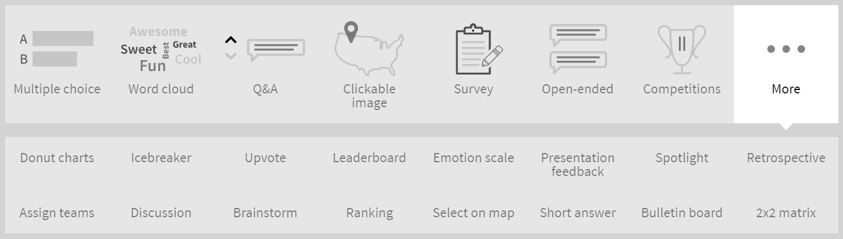
- Kahoot or Quizizz
  - These platforms are designed to assess student learning where there is one (or more) correct responses. The host is able to share their screen as applicable to the tool students respond through their mobile devices during (or after) the presentation.
  - An informative blog comparing the two quiz game platforms from an educator perspective can be found here.
- EdPuzzle
  - This may be valuable for those offering “on demand” virtual workshops or trainings.
  - Create interactive videos by embedding multiple-choice and open-ended questions throughout the video. Videos can be pulled from a variety of databases (e.g. TED Talks, Khan Academy, YouTube, etc.) or you can create and upload your own. Questions can be used to collect formative or summative data about student learning.
Examples of creative assessment strategies that may be administered using poll/quiz features include:
- Misconception/Preconception Check*
- Application Cards – Recommend using PollEverywhere Word Clouds for to visualize shorter responses
- Self Confidence Surveys* - Using a poll, can also do pre/post to measure change

Chat
Chat features generally allow of public or private messaging. Zoom has the capability to save chats at the end of a meeting for future reference.
Examples of creative assessment strategies that may be administered using chat features include:
- 3-2-1 Assessment: List 3 things you learns, 2 questions you still have, and 1 action you are going to take
- Minute Papers*
- Application Cards*
- Question of the Day/Feedback*

Breakout Rooms
Interviews and focus groups may be run concurrently using breakout room features, which allows you to split the attendees in your meeting into smaller separate sessions.
Zoom is a common video conferencing software that offers this feature. More information can be found here.

Video Observations
One of the simplest assessments of direct learning is observing students demonstrating the skills and tasks they were designed to learn through the virtual experience. Observations may be done in real time or via recording.
To conduct observations:
- Students may record themselves performing a task and send privately or share via social platforms e.g. Instagram, TikTok, Facebook, etc. as appropriate
- Use live video conferencing platform to observe skill development in real time
  - May use breakout rooms to separate students into small groups or individually if necessary and switch between rooms to conduct observations
Regardless of how the observation is done, the facilitator should always use a rubric or checklist to document the extent to which student(s) are able to perform the task/skill.

Surveys/Qualtrics
Surveys may still be conducted during/after virtual experiences. Any questions that are asked in a poll or quiz may be asked in a survey.
Qualtrics should used for longer surveys, those including open responses questions, and for ease of analysis in responses. Qualtrics is also idea if there is no poll/quiz option built into the platform used. To use a Qualtrics survey:
- Share an anonymous link to the survey in the chat
- Email a unique survey link (if tracking completion) or anonymous survey link (if not tracking completion) to participants after the experience
- Share screen with the QR code for the survey. Students will need to be able to take a picture of the QR code using their phones so they should not be using their phones to join the virtual experience

Whiteboard
Some platforms, including Zoom, allow for the sharing of whiteboards where the facilitator (and participants, if the facilitator allows) can annotate on the whiteboard. Not only can this be used for assessment purposes, but it can also be used to promote engagement in the virtual experience. This is a great option in workshops where knowledge and skill development is the focus.

Performance Indicators for Measuring Effectiveness

Outcome achievement
Ultimately, our assessment practices are determining the extent to which the experiences were effective in achieving our learning and process outcomes. Success indicators or targets should be established for each outcome prior to the experience taking place. The data collected from the various assessment strategies should be compared to the success indicators/targets for each outcome to determine the extent to which the outcomes were achieved.

Participation/Attendance
Similar to in-person experiences, it is valuable to know who is participating in the experience and not just how many. There are a number of ways to collect this information through poll, chat, surveys, etc. Some platforms may collect information from students before joining the experience.
Zoom allows participants to register for a meeting where they include their first and last name, @colorado.edu email address and other pre-generated questions or custom questions. Approval can be automatic or manual and a registration report can be downloaded.

Social Media
Engagement on social media platforms can supplement assessment practices. Examples of performance indicators may include the following. Note that not all social media platforms will track all the items below. Google Analytics may help with some tracking.
- Engagements – likes, comments, shares, etc.
- Polls
- Calls to Action
- Facebook Pages/Groups for cohort engagement
- Reach/Audience Growth Rate/Total Followers

